Final Year Project Report
Project Name

Project Advisor:
Hafiz Ahsan Arshad
Submitted By:

M. Asim Bashir | F2022266254
Rana Obaid Ur Rehman | F2022266255
Farheen Azhar | F2022266257

University of Management and Technology
C-II Johar Town Lahore Pakistan

Dedication

To our parents, the silent engineers of our souls, whose loyal belief and quiet offerings handed the bedrock upon which our bourns were erected. You gave us the roots to stay predicated and the bodies to seek the horizon.
To our instructors, especially Mr. Hafiz Ahsan Arshad, who tutored us that the language of law is but a tool to rewrite the world, and that every specialized challenge is an assignation to introduce.
And to the land that nurtured us. May this endeavor stand as a testament to the brilliance of our own soil, a small donation toward a future where our technology is as flexible and independent as our spirit.

Final Approval

- Head of Department ______________________
Department of Informatics & Systems
School of Systems & Technology
UMT Lahore

- Director (Final Year Projects-CS) ______________________
Department of Computer Science.
School of Systems & Technology
UMT Lahore

- Supervisor ______________________
- Department of Informatics & Systems.
- School of Systems & Technology
UMT Lahore

- Co-Supervisor ______________________

Acknowledgment

We express our profound gratefulness to Almighty Allah for granting us the strength, health, and perseverance needed to take over and complete this ambitious bid. We're deeply obliged to the University of Management and Technology (UMT) and the Department of Computer Science for furnishing the academic foundation and coffers necessary to transfigure a complex vision into a functional reality.

Our sincerest gratefulness goes to our advisor, Mr. Hafiz Ahsan Arshad, for his specialized mentorship and unwavering support. His guidance was necessary in helping us navigate the complications of enterprise- position software development and AI integration.

A special and significant note of appreciation is extended to the CEO of Bristol. We're truly recognized by the direct support and trust he placed in us to break a critical, real- world business problem for his association. His amenability to give us with direct access to his company's functional perceptivity was the foundation of this design. We also admit the team at Almashreqs for their cooperation in easing the integration between the mobile ecosystem and the being web structure, icing data thickness across the platform.

Eventually, we fete the cooperative spirit of every group member — Asim, Obaid, and Farheen. This design is a testament to our collaborative fidelity to creating a localized result that not only fulfills our degree conditions but also serves as a point of pride for our country’s technological geography.

Project Title: Konvert

Objective To design and develop an AI-integrated business management and sales tracking ecosystem that optimizes multitier enterprise hierarchies, streamlines distribution workflows, and provides a localized, secure alternative for data-driven decision making.

Undertaken by M. Asim Bashir ( F2022266254 )
Rana Obaid Ur Rehman ( F2022266255 )
Farheen Azhar ( F2022266257 )

Supervised by Hafiz Ahsan Arshad
Starting Date

Completion Date

Tools Used Firebase, Android Studio, Google maps API, TensorFlow and Scikit
Operating System Android 11+
Documentation

Abstract

In Pakistan's commercial landscape, businesses are often held back by fragmented data and complex foreign tools. Konvert is an AI-driven management ecosystem designed to serve as the automated backbone of an enterprise's sales operations. Built for real-world distribution challenges, it optimizes a massive eight-tier hierarchy, from Sales Representatives on the route to the CEO providing a unified "single source of truth."

By combining AI performance forecasting with real-time route tracking, Konvert automates repetitive sales tasks and reduces management overload under one secure environment. Architected for total scalability, the system specifically aims to boost Return on Investment (ROI) for businesses ranging from SMEs to large enterprises. This project is a commitment to technological sovereignty—replacing flawed foreign legacy software with a high-performance Pakistani engine designed to lead the future of national business management.

Revision Chart

Version | Primary Author(s) | Description of Version | Date Completed
1 | Rana Obaid Ur Rehman  Asim Bashir  Farheen Azhar | MVP front | 20/02/2026

Contents
Contents 1
Definitions and Acronyms 3
List of Figures 4
List of Tables 5
1. Introduction 6
1.1 Motivations 6
1.2 Project Overview 6
1.3 Problem Statement 6
1.4 Objectives 6
2. Domain Analysis 7
2.1 Customer 7
2.2 Stakeholders 7
2.3 Affected Groups with social or economic impact 7
2.4 Dependencies/ External Systems 7
2.5 Reference Documents 7
2.5.1 Related Projects 7
2.5.2 Feature Comparison 8
3. Requirements analysis 9
3.1 Requirements 9
3.2 List of Actors 10
3.3 List of use cases 10
3.4 System use case diagram 10
3.5 Extended use cases 10
3.6 User interfaces (mock screens) 12
4. Data flow diagram (optional) 13
4.1 Data Flow Diagram Level 0 13
4.2 Data Flow Diagram Level 1 13
4.3 Data Flow Diagram Level 2 13
5. System Design 15
5.1 System Architecture Diagram 15
5.2 Class Diagram 16
5.3 Collaboration Diagrams 17
5.4 Other UMLs 18
5.5 ERD 18
5.6 Data Dictionary 18
6. Implementation details 19
6.1 Development Setup 19
6.2 Deployment setup 19
6.3 Algorithms 19
6.4 Constraints 19
6.4.1 Assumptions 19
6.4.2 System constraints 19
6.4.3 Restrictions 19
6.4.4 Limitations 19
7. Testing 20
7.1 Extended Test Cases 20
7.2 Decision Table 20
7.2.1 Code snippet 20
7.2.2 Decision coverage table 20
7.3 Traceability Matrix 21
7.3.1 RID vs UCID (requirements vs use cases) 21
7.3.2 Prototypes (RID vs PID) 22
7.3.3 Test Cases (RID vs TID) 22
7.3.4 Coverage (UCID vs TID) 22
8. Results/Output/Statistics 23
8.1 %completion 23
8.2 %accuracy 23
8.3 %correctness 23
9. Conclusion 24
10. Future work 25
11. Bibliography 26
11.1 Books 26
11.2 Journals 26
11.3 Articles 26
11.4 Research papers 26
11.5 Other References 26
12. Appendix 27
12.1 Glossary of terms 27
12.2 Pre-requisites 27

Definitions and Acronyms

Acronym | Definition
UMT | University of Management and Technology
POS | Point of Sale
Table 1: table of acronyms and definitions

List of Figures

Figure 1: sample use case diagram with explanation 10
Figure 2: System Architecture 15

List of Tables
Table 1: table of acronyms and definitions 3
Table 2: list of stakeholders 7

Introduction

Motivations
Entrepreneurs with world-class products often face an immediate digital barrier because the sales management tools currently available are either prohibitively expensive foreign platforms or fragmented legacy systems that are too complex to master quickly. This creates a restrictive environment where businesses lose critical momentum navigating technical friction instead of focusing on their core commercial goals.
Furthermore, a reliance on external software introduces serious security risks and a total loss of data sovereignty. In the high-stakes field of sales management, the absence of a localized, secure, and intuitive engine means that vital business intelligence is often stored on foreign servers or lost in manual paperwork. There is an urgent need for a streamlined solution that allows Pakistani businesses to secure their data and optimize their sales workflows without the burden of unnecessary complexity or cost.

Project Overview
Konvert is a unified, AI-integrated sales ecosystem designed to synchronize field operations with strategic oversight, serving as the definitive automated backbone for Pakistani enterprises.
Moving beyond the limitations of traditional, reactive tracking software, Konvert establishes a high-performance technical bridge between mobile field operations and centralized web infrastructures. The platform is specifically architected to manage and optimize a complex eight-tier organizational hierarchy, ensuring that data generated by Sales Representatives on the route is instantly synchronized with executive dashboards. By integrating directly with existing web management systems, such as the Almashreqs infrastructure for Bristol, Konvert eliminates the fragmentation and data silos that lead to operational blind spots, establishing a real-time “Single Source of Truth’ for the entire organization.

The core of the system is a proactive intelligence engine that utilizes machine learning and advanced APIs to drive ROI through live route tracking, automated tour planning, and AI-driven performance forecasting. These predictive capabilities allow businesses to transition from defensive error-correction to proactive growth, accurately identifying future scalability and market trends. Designed for total enterprise scalability from burgeoning startups to massive distributors, the system automates mundane sales tasks and reduces operational costs while safeguarding national data sovereignty, standing as a secure domestic engine designed to empower the Pakistani workforce and catalyze national economic independence.

Problem Statement
Pakistani enterprises are currently paralyzed by a digital deadlock, caught between obsolete regional systems that fail to function and global software giants that are impossible to afford.
The reliance on fragmented, foreign legacy software has created a critical deficit in data integrity, security, and operational oversight. Organizations like Bristol are forced to navigate a dual-threat landscape:

On one side regional platforms like SanSFE offer a broken user experience and a total lack of synchronization with central systems (like Almashreqs), leading to massive data loss On the other hand world-class solutions like Salesforce or HubSpot remain financially out of reach and operationally over-engineered for the local market.

This Informational asymmetry and a total lack of bi-directional synchronization between field apps and central databases result in reporting error margins often exceeding 20%. This failure to align an eight-tier hierarchy leads to significant operational leakage and strategic pivots based on obsolete data, causing the systemic erosion of market share and net profitability.

The critical bottlenecks necessitating an immediate solution include:

Total Data Desynchronization
The absence of bi-directional sync between mobile field apps and web databases creates a high-stakes environment of record inconsistencies and redundant double-work.

Operational Stagnation
A lack of localized, AI-driven route optimization and tour planning forces field representatives into inefficient workflows, resulting in massive resource wastage.

Strategic Blindness
Executive leadership (from Managers to the CEO) is forced to operate without real-time visibility or predictive performance forecasting, leading to reactive rather than proactive management.

Loss of Sovereignty
Entrusting national commercial intelligence to foreign servers creates deep-seated data-privacy vulnerabilities and long-term geopolitical risks.

Economic Exclusion
Prohibitive foreign subscription costs and steep learning curves ensure that local startups and SMEs remain technologically underdeveloped.

Failure to solve these issues will result in a permanent technological dependency, where Pakistani businesses continue to bleed capital to foreign entities while operating on flawed data. Without a secure, domestic automated backbone, our industries will remain trapped in strategic blindness, unable to compete in a global economy that demands real-time intelligence and technological sovereignty.

You can read more about the problems of sales management in this digital world and its impact here:
HubSpot: 2025/2026 Sales Trends Report
Salesforce: 2026 State of Sales Statistics
MarketsandMarkets: The ROI Gap Analysis (via MeetRep)

Objectives
Our objective is to develop the definitive automated backbone for Pakistani businesses, transforming fragmented field data into a synchronized engine for strategic growth and national economic resilience. To achieve the following strategic and technical milestones:
- Establish Absolute Data Synchronization
- To engineer a unified, bi-directional engine that bridges the gap between field-level mobile applications and central web databases, ensuring a “single source of truth'' across all organizational tiers.
- Automate Strategic Backbone Workflows
- To dismantle management overload by automating administrative sales tasks, reporting cycles, and inventory tracking, allowing leaders to shift from manual oversight to strategic growth.
- Optimize Operational Intelligence via AI
- To deploy AI-driven performance analytics and future forecasting modules that transform raw field data into actionable predictions and scalable roadmaps.
- Maximize Business ROI through Localized Efficiency
- To increase the Return on Investment (ROI) for Pakistani enterprises by providing elite-tier route optimization and tour planning features at a fraction of the cost of foreign alternatives.
- Safeguard National Data Sovereignty
- To develop a secure, domestic business management environment that keeps critical commercial intelligence within Pakistan's borders, mitigating geopolitical and privacy risks.
- Catalyze Enterprise Scalability
- To build a flexible architecture that empowers businesses of all sizes from burgeoning startups to massive eight-tier distributors---to scale their operations without technical friction.

We aim to revolutionize the way businesses operate in Pakistan by transforming sales management from a manual, high-friction chore into a proactive, data-driven engine. By providing an elite-tier technical infrastructure that is intuitive and affordable, we empower local industries to scale rapidly and maintain strategic momentum without relying on flawed or inaccessible foreign software.

Domain Analysis

Customer
The success of Konvert depends on a granular understanding of the customers who will utilize this engine as their automated backbone. Our analysis identifies two primary enterprise segments and three distinct user archetypes.

2.1.1

Enterprise Segments:

Large-Scale Pharmaceutical and Distribution Enterprises
These organizations manage massive operations characterized by an eight-tier hierarchy. Their primary pain point is informational asymmetry—where field data takes days to reach the executive level. For these customers, Konvert provides a unified environment that eliminates data silos and ensures that strategic decisions are based on real-time field intelligence rather than obsolete reports.

Small and Medium Enterprises (SMEs)
SMEs represent the majority of the Pakistani business landscape but are often excluded from high-tier sales technology due to prohibitive costs. Konvert offers these customers a scalable, localized, and affordable alternative to global giants. This segment values the system's ability to automate mundane tasks, allowing them to grow their operations without a proportional increase in administrative overhead.

2.1.2

User Archetypes:
Executive Leadership
CEO and C-Suite
Executives require high-level, actionable insights. They use the system to monitor national sales trends, evaluate regional performance, and utilize AI forecasting to plan future market expansions. Their goal is the protection of market share and the optimization of long-term ROI.

Sales Managers
Tier 2-7
Mid-level managers are responsible for team productivity. They rely on Konvert to dismantle management overload by utilizing automated reporting and real-time oversight. The system allows them to identify underperforming routes and provide data-driven coaching to their teams.
Field Sales Representatives
Tier 8
The primary generators of data, field representatives require a tool that reduces administrative friction. They utilize the mobile interface for live route tracking, automated tour planning, and inventory management. For this archetype, the value lies in spending less time on paperwork and more time on active sales.

.

Stakeholders
The Konvert ecosystem involves several internal and external stakeholders whose collaboration is essential for the technical deployment and operational success of the system.

2.2.1

Internal Stakeholders:

Project Development Team
Asim Bashir, Rana Obaid Ur Rehman, Farheen Azhar
Technical architects responsible for the full stack engineering, AI model training, and the implementation of the bi directional synchronization logic.

Project Advisor

Hafiz Ahsan Arshad
Strategic consultant and technical validator who oversees the development lifecycle to ensure it adheres to professional software engineering standards and academic requirements.

2.2.1

External Stakeholders:

Bristol Mayer Biotech

Abdul Razzaq (Business unit head)
The lead industry pilot and primary end-user group. Their role is to provide the operational context and act as the primary testing ground for the eight-tier hierarchical visibility.

Almashreqs Soft.

Bashir Ahmed (CEO)
Infrastructure partner managing the central web database. Their role is critical in providing secure API endpoints and ensuring the technical compatibility of the web-to-mobile data bridge.

Local SME Sector (Optional for FYP):
Secondary stakeholder group acting as market validators. Their role is to provide feedback on the system's affordability and ease of adoption for non-enterprise businesses.

Affected Groups with social or economic impact

The implementation of Konvert generates a ripple effect across various social and economic strata, influencing how labor is utilized and how national capital is retained.
Social Impact

Labor Upskilling and Digital Inclusion
Konvert acts as a catalyst for social mobility within the commercial workforce. By automating mundane administrative tasks, it empowers lower-tier field workers to transition from clerical data entry to high-value strategic selling. Furthermore, its intuitive interface promotes digital inclusion, allowing individuals from varied educational backgrounds to navigate complex enterprise systems with minimal training. This reduces the “technical intimidation” barrier, fostering a more agile and digitally-literate workforce in Pakistan.

Economic Impact

Capital Retention and National Growth
On a macroeconomic scale, Konvert contributes to Pakistan's economic resilience by promoting technological sovereignty. By providing a domestic alternative to foreign-managed CRM/ERP systems, it prevents the outflow of capital currently spent on international subscription fees. Locally, it empowers SMEs—the engines of national growth—to compete with large-scale distributors by providing them with elite-tier analytical tools at a fraction of the cost, thereby catalyzing broad-market competitiveness and innovation.

Organizational Impact

Structural Efficiency
Within an organization, Konvert shifts the culture from reactive error-correction to proactive growth. By eliminating the informational asymmetry that typically plagues multi-tier hierarchies, it reduces internal friction and allows departments to operate in synchronization. This structural efficiency leads to lower operational overhead and higher net profitability, creating a more sustainable business model for Pakistani enterprises.

Dependencies/ External Systems
The functionality of Konvert is contingent upon a robust infrastructure of external services and technical dependencies that provide the specialized capabilities required for enterprise-level sales management.

Centralized Web Infrastructure (Almashreqs)
The existing web-based business infrastructure managed by Almashreqs serves as the legacy data source. Konvert relies on custom API bridges to pull user hierarchies and push field activity logs to the central Bristol servers.

Geospatial Services (Google Maps API)
The system integrates the Google Maps Platform for geocoding, real-time salesman tracking, and route distance calculations. This is essential for validating field attendance and optimizing tour plans.

Machine Learning Frameworks
The AI engine depends on Scikit-learn and TensorFlow for training predictive performance models. These libraries allow the system to process historical field data and generate future sales outlooks.

Google Firebase Ecosystem
The system utilizes Google Firebase for real-time infrastructure, employing Firestore for NoSQL data synchronization, Cloud Messaging (FCM) for instant notifications, and Firebase Authentication for secure identity management and session control.

Identity and Security Services
Google Authenticator is integrated to provide Multi-Factor Authentication (MFA), securing executive-level access and sensitive commercial data.

Reference Documents

Related Projects
To accurately position Konvert within the current technological landscape, we conducted a critical analysis of existing solutions currently serving the regional and global markets.

Regional Industry Leader

SanSFE (Regional Industry Leader)
Primarily utilized within the pharmaceutical distribution sectors of South Asia, SanSFE represents the legacy baseline. While it provides basic field reporting, it suffers from a critical lack of real-time bi-directional synchronization. Data generated on the mobile frontend often requires manual reconciliation with central web servers, leading to significant latency and high error margins in hierarchical reporting.
Global Enterprise CRM Solutions

Salesforce, HubSpot
These platforms represent the gold standard in sales management. While technically superior, they are largely unsuitable for the Pakistani SME and distribution landscape. Their prohibitive dollar-based subscription costs create a massive financial barrier, and their generalized architectures often require expensive third-party consultants to customize for localized pharmaceutical or multi-tier distribution workflows.
Smaller competition

Localized Legacy ERPs
Many local enterprises utilize custom-built or older ERP systems. These systems are typically desktop-bound or web-only, lacking the robust mobile integration required for field force tracking. They operate as static record-keeping tools rather than proactive engines, offering no geospatial tracking or AI-driven predictive analytics to assist in route planning or performance forecasting.

Feature Comparison
Feature Attribute | SanSFE (Regional) | Global CRM (Salesforce) | Requirement Gap
Data Sync | Manual reconciliation. | High-speed cloud sync. | Localized bi-directional flow.
Mobile UI | Outdated legacy design. | Modern but complex. | Simplified field-force UX.
Reporting | Static PDF logs. | Advanced BI dashboards. | Automated localized metrics.
Cost | Moderate localized. | Prohibitive dollar-based. | Affordability for local SME.
Visibility | Immediate superior only. | Customizable/Complex. | Native 8-tier hierarchy.
Intelligence | Record-based only. | High-cost AI add-ons. | Built-in native AI engine.
Offline Work | Poor/Unstable. | Basic/Cloud-dependent. | Robust offline-first engine.
Onboarding | Lengthy setup. | Long consultant cycles. | Agile rapid deployment.
Support | Limited regional. | Remote/Indirect. | Direct local engineering.

Requirements analysis

Requirements

Functional Requirements
The functional requirements define the operational capabilities required for Konvert to serve as a comprehensive sales backbone.

FR Module 1

Initialization, Security, and Access Control

FR-1.

System Startup Checks
The app must perform security, stability, and update checks during the splash screen sequence before granting access.

FR-2.

Error Handling and Recovery
The system must provide self-healing options (cache clear, database resync, reinstall) in response to runtime errors.

FR-3.

Domain and Hierarchy Onboarding
Users must be able to connect to a specific company domain (e.g., Bristol) via API keys and retrieve the specific 8-tier hierarchy.

FR-4.

Multi-Factor Authentication (MFA)
Login must be secured via Google Authenticator tokens, validated against the Almashreqs database hash.

FR-5.

Feature Locking Mechanism
The app must restrict feature access dynamically based on the user's specific role within the retrieved hierarchy.

FR Module 2

Data Synchronization and Persistence

FR-6.

Master Sync Protocol
The system must perform a full synchronization with the Almashreq cloud CRM upon login, downloading only data relevant to the specific UserID.

FR-7.

Bi-Directional Real-Time Sync
Field data (orders, logs) must sync instantly with Firebase Firestore; web-side updates must push to the mobile app immediately.

FR-8.

Offline-First Architecture
The app must remain fully functional without internet, queueing all transactions for automatic upload upon reconnection.

FR Module 3

Intelligent Dashboard and Analytics

FR-9.

AI Performance Prediction
The dashboard must display an AI-generated forecast of the user's weekly success probability based on historical behavioral patterns.

FR-10.

Target Visualization
Real-time graphs must show daily and weekly target achievement progress derived from the active tour plan.

FR-11.

Automated Notification System
A background checker must fetch and display prioritized alerts (warnings, updates, approvals) via a dedicated notification center.

FR-12.

Advanced Reporting Module
The system must generate detailed performance reports with granular filtering (daily, weekly, categorical) using cloud reporting APIs.

FR Module 4

Tour Planning and Roadmap

FR-13.

Automated Tour Plan Creation
Users must be able to create new tour plans by selecting dates, routes, and expense budgets.

FR-14.

AI Enhancement ("Enhance Button")
The system must offer an AI-helper class to optimize the tour plan for maximum efficiency before submission.

FR-15.

Management Approval Workflow
Submitted tour plans must lock upon creation and unlock only after receiving digital approval signals from the management tier.

FR Module 5

Fieldwork and Geospatial Operations

FR-16.

Integrated Route Navigation
The fieldwork interface must embed Google Maps to show the route to the next customer without external app switching.

FR-17.

Geo-Fencing Triggers
Product selection buttons must only become active when the user's GPS coordinates enter a defined radius of the customer's location.

FR-18.

Quick-Update Mechanism
The fieldwork page must allow for rapid, localized data fetching from the server without requiring a full Master Sync.

FR Module 6

Order Management and Booking

FR-19.

Dynamic Product Selection
The system must allow users to select OTC and Regular products, applying discounts and bonuses based on current logic.

FR-20.

Daily Booking Summary
Users must be able to review, edit, and confirm daily bookings before final submission.

FR-21.

End-of-Day Upload
The system must compile all daily bookings and upload them to the Almashreqs cloud CRM for final administrative approval.

Non-Functional Requirements
The non-functional requirements define the quality attributes, design constraints, and performance benchmarks of the system.

NFR Module 1

Performance and Efficiency

NFR-1.
Rendering and Sync Speed
The Flutter UI must maintain 60 FPS for smooth navigation, and the initial Master Sync must complete within 15 seconds on a standard 4G connection.

NFR-2.
Battery Optimization
Background services, including continuous 5-minute GPS polling and AI data gathering, must consume less than 15% of device battery over an 8-hour shift.

NFR Module 2

Reliability and Availability

NFR-3.
Offline Resilience
The system must guarantee zero data loss during network dropouts by utilizing robust local caching before attempting Firebase synchronization.

NFR-4.

High Availability
The cloud infrastructure and Almashreqs API bridges must maintain a 99.9% uptime SLA to ensure uninterrupted executive monitoring and data flow.

NFR Module 3

Security and Compliance

NFR-5.
Encryption Standards
All data in transit must be secured via TLS 1.3, and local cache data (like customer PII and bookings) must be encrypted using AES-256.

NFR-6.
Breach Management
The system must auto-expire idle sessions and instantly wipe local data while alerting admins if a device security breach or root is detected.

NFR Module 4

Scalability and Maintainability

NFR-7.
Concurrent Architecture
The Firebase NoSQL structure and API bridges must be optimized to handle 5,000+ simultaneous active field agents without write-lock bottlenecks.

NFR-8.
Application Updates
The system must support forced mandatory updates and optional delayed updates (1-2 days) to ensure all tiers operate on the same compliant software version.

NFR Module 5
Usability and Compatibility

NFR-9.
Hardware Compatibility
The application must operate efficiently on lower-tier mobile devices (minimum 2GB RAM) typically deployed to regional field representatives.

NFR-10.
Human Centered UX
Adhering to ISO 9241-210 standards, core field workflows (check-in, booking) must be achievable within three screen taps to minimize user friction.

List of Actors
The Konvert system interacts with the following stakeholders across the enterprise landscape:
- Executive Leadership (CEO / Business Unit Head)
- Tactical Managers (National / Regional / Zonal / Area)
- Operations Support (Command Center Operatives)
- Field Sales Representatives (Tier 8)
- System Administrator

List of use cases
UC-01 | Initialize System and Perform Application Startup Checks
UC-02 | Handle Application Errors and Execute Recovery Options
UC-03 | Download and Install Mandatory or Optional Updates
UC-04 | Detect and Report System Security Breaches
UC-05 | Onboard User and Configure Enterprise Domain Connection
UC-06 | Retrieve Hierarchy and Select Business Role
UC-07 | Authenticate User via Google Authenticator MFA
UC-08 | Execute User-Specific Master Data Synchronization
UC-09 | View AI-Powered Predictive Performance Dashboard
UC-10 | Monitor Target Goals, Promotions, and Notifications
UC-11 | Manage User Profile, Theme, and Application Settings
UC-12 | View and Filter Prioritized System Notifications
UC-13 | Generate and Filter Advanced Cloud-Based Reports
UC-14 | View and Filter Allocated Enterprise Resources
UC-15 | Track and Manage Current Route Roadmap
UC-16 | Create and Configure New Route Tour Plan
UC-17 | Optimize Tour Plan via AI Enhancement Tool
UC-18 | Approve or Reject Submitted Tour Plans
UC-19 | Navigate Assigned Route via Integrated Google Maps
UC-20 | Execute Quick Data Update for Localized Assets
UC-21 | Trigger Geo-Fenced Customer Product Selection
UC-22 | Select Products, Discounts, and Configure Orders
UC-23 | Review, Edit, and Confirm Customer Bookings
UC-24 | Upload End-of-Day Bookings to Central Cloud CRM

System use case diagram
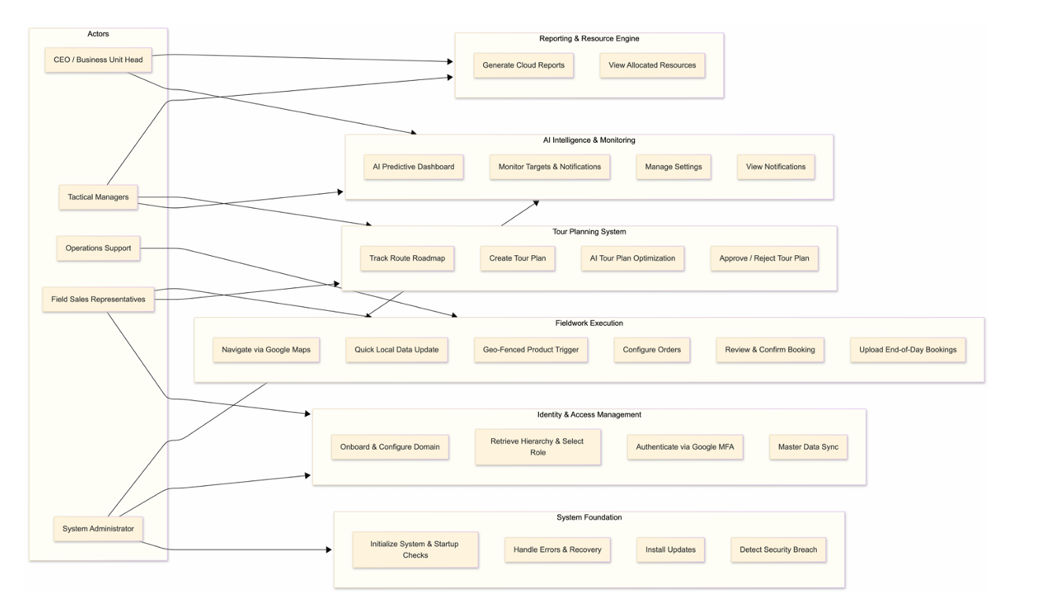

Figure 1: sample use case diagram with explanation

Extended use cases

UC-01

Initialize System and Perform Application Startup Checks
Field | Description
Use Case ID | UC-01
Name | Initialize System and Perform Application Startup Checks
Primary Actor | Sales Representative (Business User)
Supporting Actors | Almashreq CRM API, Firebase, Update Server
Preconditions | App is installed on device
Trigger | User launches the Konvert mobile app
Main Flow | 1. Display splash screen animation. 2. Perform app integrity check. 3. Perform update availability check. 4. Perform security status validation. 5. Validate stored login token (if exists). 6. Check pending sync requirements. 7. Redirect user to appropriate next page (Login / Master Sync / Dashboard / Update / Error / Security).
Alternate Flows | A1: If update mandatory → Redirect to Update Page. A2: If security breach detected → Redirect to Security Page. A3: If data mismatch → Redirect to Master Sync. A4: If first launch → Redirect to Onboarding. A5: If startup error occurs → Redirect to Error Page.
Postconditions (Success) | App transitions to appropriate operational state.
Postconditions (Failure) | User is shown error recovery options.
Business Rules | Startup validation must complete within performance limits (NFR-1).

UC-02

Handle Application Errors and Execute Recovery Options
Field | Description
Use Case ID | UC-02
Name | Handle Application Errors and Execute Recovery Options
Primary Actor | Sales Representative
Supporting Actors | Local Storage Engine, Update Server
Preconditions | System detects startup or runtime failure
Trigger | Error condition raised by system
Main Flow | 1. Display error details to user. 2. Provide contextual recovery options: • Restart App • Clear Cache • Clear Local Database • Resync Data • Update App • Reinstall via Play Store
Alternate Flows | A1: If cache clear resolves issue → Restart to Splash. A2: If database cleared → Redirect to Master Sync. A3: If update required → Redirect to Update Page.
Postconditions (Success) | App restored to stable working condition.
Postconditions (Failure) | User instructed to reinstall application.
Business Rules | Zero corruption tolerance for synced CRM data (NFR-3).

UC-03

Download and Install Mandatory or Optional Updates
Field | Description
Use Case ID | UC-03
Name | Download and Install Mandatory or Optional Updates
Primary Actor | Sales Representative
Supporting Actors | Update Server, Google Play API
Preconditions | Update detected during startup or background check
Trigger | System flags available update
Main Flow | 1. Display update information (version, importance). 2. If mandatory → Begin automatic download. 3. Lock app access until update completes. 4. Restart app after successful installation.
Alternate Flows | A1: If optional → Allow user 1–2 day delay. A2: If download fails → Show retry option.
Postconditions (Success) | Application updated and relaunched.
Postconditions (Failure) | App remains unusable until mandatory update completes.
Business Rules | Version consistency required across hierarchy tiers (NFR-8).

UC-04

Detect and Report System Security Breaches
Field | Description
Use Case ID | UC-04
Name | Detect and Report System Security Breaches
Primary Actor | System (Automated Security Engine)
Supporting Actors | System Admin, Almashreq CRM Security API
Preconditions | App running in foreground or background
Trigger | Security anomaly detected (root access, tampering, unauthorized modification)
Main Flow | 1. Detect abnormal security condition. 2. Validate breach authenticity. 3. Auto-expire active sessions. 4. Wipe encrypted local data (if severe). 5. Send breach report to admin. 6. Redirect user to Security Page.
Alternate Flows | A1: Minor warning → Notify user but allow limited usage. A2: Severe breach → Lock app completely.
Postconditions (Success) | System integrity preserved.
Postconditions (Failure) | App access denied.
Business Rules | Must comply with TLS 1.3 & AES-256 encryption standards (NFR-5).

UC-05

Onboard User and Configure Enterprise Domain Connection
Field | Description
Use Case ID | UC-05
Name | Onboard User and Configure Enterprise Domain Connection
Primary Actor | Sales Representative
Supporting Actors | Almashreq CRM API
Preconditions | App launched for first time
Trigger | First-time app access
Main Flow | 1. Collect user preferences (theme, language). 2. Display app introduction modal. 3. Present Terms of Service agreement. 4. User enters domain address + API key. 5. Validate domain with Almashreq CRM. 6. Retrieve company hierarchy structure. 7. Allow user to select role. 8. Redirect to Login Page.
Alternate Flows | A1: Invalid API key → Display error and retry option. A2: Domain unreachable → Show network error and retry.
Postconditions (Success) | App configured for specific enterprise instance.
Postconditions (Failure) | User cannot proceed to login.
Business Rules | Hierarchy determines feature-lock configuration (FR-5).

UC-06

Retrieve Hierarchy and Select Business Role
Field | Description
Use Case ID | UC-06
Name | Retrieve Hierarchy and Select Business Role
Primary Actor | Sales Representative
Supporting Actors | Almashreq CRM API
Preconditions | Valid domain + API key submitted (UC-05 completed)
Trigger | Successful enterprise domain validation
Main Flow | 1. System requests hierarchy structure from Almashreq CRM. 2. CRM returns 8-tier business hierarchy. 3. System checks if customer module enabled (v1.0 disabled). 4. Display role selection interface. 5. User selects their business role. 6. System stores selected hierarchy role locally. 7. Redirect to Login Page.
Alternate Flows | A1: Hierarchy fetch fails → Show retry option. A2: No role available → Deny access.
Postconditions (Success) | Role stored and feature-lock rules prepared.
Postconditions (Failure) | Onboarding halted.
Business Rules | Role determines feature access via Feature Lock Engine (FR-5).

UC-07

Authenticate User via Google Authenticator MFA
Field | Description
Use Case ID | UC-07
Name | Authenticate User via Google Authenticator MFA
Primary Actor | Sales Representative
Supporting Actors | Almashreq Database, Google Authenticator API
Preconditions | Role selected, login page active
Trigger | User submits login credentials
Main Flow | 1. Validate username/password with Almashreq database. 2. If valid → Prompt MFA token. 3. User enters Google Authenticator OTP. 4. System verifies OTP hash against database. 5. Generate secure session token. 6. Store encrypted token locally. 7. Redirect to Master Sync.
Alternate Flows | A1: Invalid credentials → Show error. A2: Invalid OTP → Retry limit enforced. A3: Session token mismatch → Force re-login.
Postconditions (Success) | Authenticated session established.
Postconditions (Failure) | Access denied.
Business Rules | MFA mandatory for all business-tier users (FR-4, NFR-5).

UC-08

Execute User-Specific Master Data Synchronization
Field | Description
Use Case ID | UC-08
Name | Execute User-Specific Master Data Synchronization
Primary Actor | Sales Representative
Supporting Actors | Almashreq CRM API, Firebase Firestore
Preconditions | Authenticated session exists
Trigger | Successful login or manual sync
Main Flow | 1. Initiate secure cloud connection. 2. Fetch data limited to current UserID. 3. Download customers, resources, targets, tour plan, permissions. 4. Encrypt and cache locally. 5. Validate data integrity. 6. Redirect to Dashboard.
Alternate Flows | A1: Network failure → Retry or enable offline mode. A2: Data corruption → Redirect to Error Page.
Postconditions (Success) | Local database synced and ready for offline-first operation.
Postconditions (Failure) | User restricted until sync completes.
Business Rules | Master Sync must complete within 15 seconds (NFR-1).

UC-09

View AI-Powered Predictive Performance Dashboard
Field | Description
Use Case ID | UC-09
Name | View AI-Powered Predictive Performance Dashboard
Primary Actor | Sales Representative
Supporting Actors | AI Analytics Engine, Reporting API
Preconditions | Master Sync completed
Trigger | User opens Dashboard Home Tab
Main Flow | 1. Load weekly progress data. 2. Run AI behavioral analysis model. 3. Generate success probability forecast. 4. Display prediction graph and insights.
Alternate Flows | A1: AI model unavailable → Display historical performance only.
Postconditions (Success) | User views predictive performance insights.
Postconditions (Failure) | AI disabled, dashboard still functional.
Business Rules | AI forecast must be derived from company dataset (FR-9).

UC-10

Monitor Target Goals, Promotions, and Notifications
Field | Description
Use Case ID | UC-10
Name | Monitor Target Goals, Promotions, and Notifications
Primary Actor | Sales Representative
Supporting Actors | Notification Engine, Promotion API
Preconditions | Dashboard active
Trigger | User opens Home Tab
Main Flow | 1. Display daily and weekly targets. 2. Fetch active promotion banner. 3. Display latest prioritized notification. 4. Show optional ad banner (if enabled).
Alternate Flows | A1: Promotion unavailable → Hide banner. A2: No notifications → Show placeholder.
Postconditions | User informed of operational priorities.
Business Rules | Targets must match approved Tour Plan data.

UC-11

Manage User Profile, Theme, and Application Settings
Field | Description
Use Case ID | UC-11
Name | Manage User Profile, Theme, and Application Settings
Primary Actor | Sales Representative
Supporting Actors | Local Settings Manager
Preconditions | User logged in
Trigger | User opens Settings Page
Main Flow | 1. Display profile details. 2. Allow theme and language changes. 3. Toggle automation features. 4. Save preferences locally. 5. Provide logout option.
Alternate Flows | A1: Logout selected → Clear token and redirect to Login.
Postconditions | Updated preferences stored and applied instantly.
Business Rules | Session token must be wiped upon logout (NFR-6).

UC-12

View and Filter Prioritized System Notifications
Field | Description
Use Case ID | UC-12
Name | View and Filter Prioritized System Notifications
Primary Actor | Sales Representative
Supporting Actors | Notification Engine, Firebase
Preconditions | User logged in
Trigger | User opens Notification Page
Main Flow | 1. Fetch categorized notifications. 2. Sort by priority (High / Medium / Low). 3. Allow filtering options. 4. Mark notification as read.
Alternate Flows | A1: Offline mode → Show cached notifications only.
Postconditions | Notifications updated and synced.
Business Rules | Real-time updates must be supported (FR-11, FR-7).

UC-13

Generate and Filter Advanced Cloud-Based Reports
Field | Description
Use Case ID | UC-13
Name | Generate and Filter Advanced Cloud-Based Reports
Primary Actor | Sales Representative
Supporting Actors | Almashreq Reporting API, Chart/Visualization API
Preconditions | User authenticated and Master Sync completed
Trigger | User opens Reporting Tab
Main Flow | 1. System establishes secure API connection. 2. Fetch user-specific reporting dataset. 3. Display summary KPIs. 4. Provide filtering options (daily, weekly, monthly, category, product, region). 5. Render charts dynamically using reporting APIs. 6. Update data view based on selected filters.
Alternate Flows | A1: Network unavailable → Show last cached report snapshot. A2: API error → Display error and retry option.
Postconditions (Success) | User views detailed performance analytics.
Postconditions (Failure) | Reporting limited to cached data.
Business Rules | Reports must reflect real-time cloud data consistency (FR-12, FR-7).

UC-14

View and Filter Allocated Enterprise Resources
Field | Description
Use Case ID | UC-14
Name | View and Filter Allocated Enterprise Resources
Primary Actor | Sales Representative
Supporting Actors | Almashreq CRM API
Preconditions | Master Sync completed
Trigger | User opens Resource Tab
Main Flow | 1. Load locally cached resource dataset. 2. Display categorized resources (customers, products, bricks, locations). 3. Allow advanced filtering (area, product type, status). 4. Display detailed resource information on selection.
Alternate Flows | A1: Data outdated → Prompt quick update (UC-20).
Postconditions | User accesses allocated operational assets.
Business Rules | User can only view resources assigned to their UserID (FR-6).

UC-15

Track and Manage Current Route Roadmap
Field | Description
Use Case ID | UC-15
Name | Track and Manage Current Route Roadmap
Primary Actor | Sales Representative
Supporting Actors | Local Database, Tour Plan Module
Preconditions | Approved tour plan exists
Trigger | User opens Roadmap Tab
Main Flow | 1. Retrieve current approved tour plan. 2. Display roadmap timeline (Completed / In Progress / Upcoming). 3. Show daily targets tied to route stops. 4. Highlight next customer.
Alternate Flows | A1: No tour plan found → Prompt to create new plan (UC-16).
Postconditions | User has clear visibility of route execution progress.
Business Rules | Only approved tour plans are actionable.

UC-16

Create and Configure New Route Tour Plan
Field | Description
Use Case ID | UC-16
Name | Create and Configure New Route Tour Plan
Primary Actor | Sales Representative
Supporting Actors | Resource Module, Management Approval System
Preconditions | No active approved tour plan OR update request approved
Trigger | User selects “Create / Update Tour Plan”
Main Flow | 1. Load allocated resources. 2. User selects dates, timing, routes, customers. 3. Define daily targets and expenses. 4. Validate route constraints. 5. Save draft tour plan. 6. Submit to management for approval. 7. Lock plan until approval response.
Alternate Flows | A1: Validation error → Highlight incorrect inputs. A2: User cancels → Discard draft.
Postconditions | Tour plan submitted and pending approval.
Business Rules | Plan must align with allocated resources and hierarchy permissions (FR-13, FR-15).

UC-17

Optimize Tour Plan via AI Enhancement Tool
Field | Description
Use Case ID | UC-17
Name | Optimize Tour Plan via AI Enhancement Tool
Primary Actor | Sales Representative
Supporting Actors | AI TourPlanHelper Engine
Preconditions | Tour plan draft exists
Trigger | User presses “Enhance” button
Main Flow | 1. Send draft tour plan data to AI engine. 2. Analyze route efficiency, workload balance, target distribution. 3. Suggest optimized customer order and expense adjustments. 4. Present optimization preview. 5. User accepts or rejects modifications.
Alternate Flows | A1: AI unavailable → Disable enhancement feature.
Postconditions | Optimized tour plan saved (if accepted).
Business Rules | AI must operate within allocated resource constraints (FR-14).

UC-18

Approve or Reject Submitted Tour Plans
Field | Description
Use Case ID | UC-18
Name | Approve or Reject Submitted Tour Plans
Primary Actor | Management Tier (Area/Regional Manager)
Supporting Actors | Notification Engine, Tour Plan Module
Preconditions | Tour plan submitted (UC-16 completed)
Trigger | Manager reviews submitted plan
Main Flow | 1. Manager views tour plan details. 2. Evaluate targets, route logic, expenses. 3. Approve or Reject digitally. 4. If approved → Lock plan and notify user. 5. If rejected → Send feedback note to user.
Alternate Flows | A1: Manager requests modification → Return editable state to user.
Postconditions (Approval) | Tour plan becomes active and immutable.
Postconditions (Rejection) | User notified and allowed to revise.
Business Rules | Approval required before roadmap execution begins (FR-15).

UC-19

Navigate Assigned Route via Integrated Google Maps
Field | Description
Use Case ID | UC-19
Name | Navigate Assigned Route via Integrated Google Maps
Primary Actor | Sales Representative
Supporting Actors | Google Maps API, GPS Module
Preconditions | Approved tour plan exists (UC-18 completed)
Trigger | User presses “Start Field Work”
Main Flow | 1. Retrieve next customer from active roadmap. 2. Fetch GPS coordinates. 3. Embed Google Maps view within Fieldwork page. 4. Display optimized route and distance. 5. Continuously update live position.
Alternate Flows | A1: GPS disabled → Prompt user to enable location services. A2: Network unavailable → Display offline map with limited functionality.
Postconditions | User actively navigates to next assigned customer.
Business Rules | Route must align strictly with approved tour plan.

UC-20

Execute Quick Data Update for Localized Assets
Field | Description
Use Case ID | UC-20
Name | Execute Quick Data Update for Localized Assets
Primary Actor | Sales Representative
Supporting Actors | Almashreq CRM API
Preconditions | User on Fieldwork Page
Trigger | User presses “Update” button
Main Flow | 1. Send request for selective resource refresh. 2. Fetch updated product pricing, targets, or customer data. 3. Merge updated data into local cache. 4. Confirm update completion.
Alternate Flows | A1: Network failure → Retry option.
Postconditions | Localized data refreshed without full Master Sync.
Business Rules | Must not trigger full data reload (FR-18).

UC-21

Trigger Geo-Fenced Customer Product Selection
Field | Description
Use Case ID | UC-21
Name | Trigger Geo-Fenced Customer Product Selection
Primary Actor | Sales Representative
Supporting Actors | GPS Module, Geo-Fencing Engine
Preconditions | User navigating to customer location
Trigger | User enters predefined radius around customer
Main Flow | 1. Continuously monitor GPS location. 2. Compare current coordinates with customer radius. 3. If within range → Activate Product Selection button. 4. Allow transition to Product Tab.
Alternate Flows | A1: Outside radius → Button remains disabled. A2: GPS manipulation detected → Trigger security warning.
Postconditions | Product selection access granted only within valid location.
Business Rules | Geo-fencing mandatory before booking (FR-17).

UC-22

Select Products, Discount, and Configure Orders
Field | Description
Use Case ID | UC-22
Name | Select Products, Discounts, and Configure Orders
Primary Actor | Sales Representative
Supporting Actors | Local Product Engine
Preconditions | Geo-fence validated (UC-21 completed)
Trigger | User enters Product Selection Tab
Main Flow | 1. Display OTC products. 2. User selects quantity, discount, bonus. 3. Add products to temporary cart. 4. Display running total against target. 5. Allow editing/removal of selected items. 6. Validate minimum acceptable target threshold. 7. Enable “Confirm Booking” button.
Alternate Flows | A1: Target not met → Warn user but allow override (if policy permits).
Postconditions | Order ready for confirmation.
Business Rules | Discounts and bonuses must comply with cloud-defined logic (FR-19).

UC-23

Review, Edit, and Confirm Customer Bookings
Field | Description
Use Case ID | UC-23
Name | Review, Edit, and Confirm Customer Bookings
Primary Actor | Sales Representative
Supporting Actors | Local Booking Module
Preconditions | Products selected
Trigger | User confirms booking
Main Flow | 1. Store booking locally in encrypted database. 2. Display booking summary in Bookings Page. 3. Allow editing of individual bookings. 4. Update running total for the day.
Alternate Flows | A1: User edits booking → Return to Product Tab.
Postconditions | Booking safely stored for end-of-day upload.
Business Rules | Offline-first guarantee applies (NFR-3).

UC-24

Upload End-of-Day Bookings to Central Cloud CRM
Field | Description
Use Case ID | UC-24
Name | Upload End-of-Day Bookings to Central Cloud CRM
Primary Actor | Sales Representative
Supporting Actors | Almashreq CRM API, Firebase Sync Engine
Preconditions | At least one booking exists
Trigger | User presses “Confirm End-of-Day Booking”
Main Flow | 1. Compile all daily bookings. 2. Encrypt payload via TLS 1.3. 3. Upload to Almashreq cloud CRM. 4. Await acknowledgment response. 5. Mark bookings as submitted. 6. Notify system admin for review and approval.
Alternate Flows | A1: Network failure → Queue upload and retry automatically. A2: Upload rejected → Display rejection note in notifications.
Postconditions (Success) | Bookings successfully transmitted to central system.
Postconditions (Failure) | Data retained locally until successful upload.
Business Rules | Must comply with encryption and zero-loss guarantee (NFR-5, NFR-3).

User interfaces (mock screens)
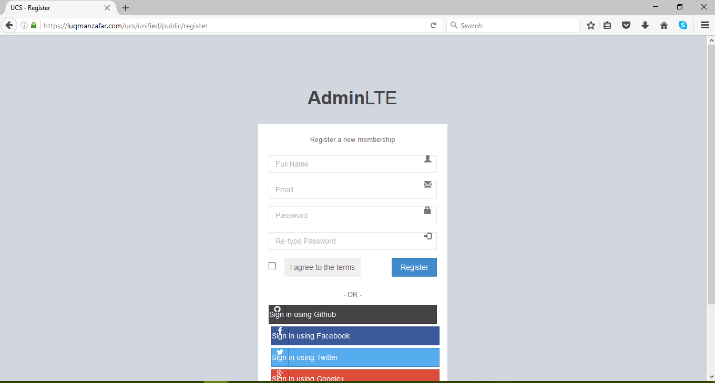
Prototype1: (P1) register a new member

Data flow diagram (optional)

Data Flow Diagram Level 0
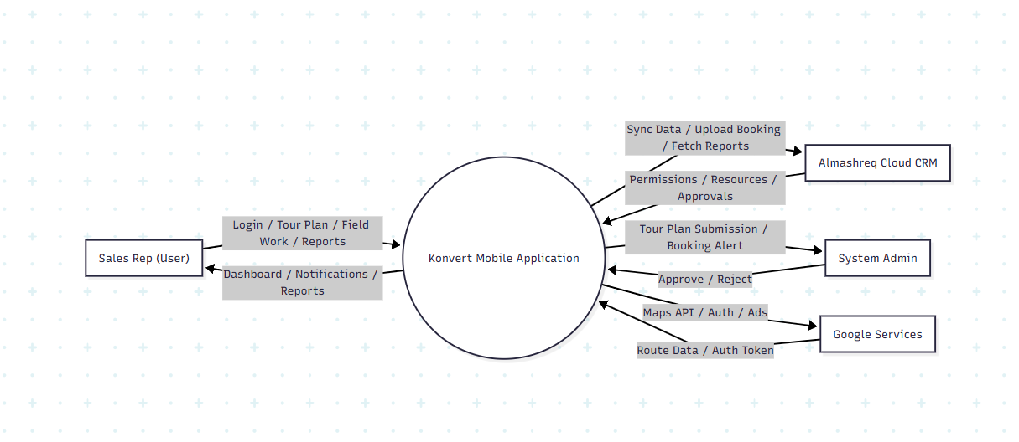

Data Flow Diagram Level 1
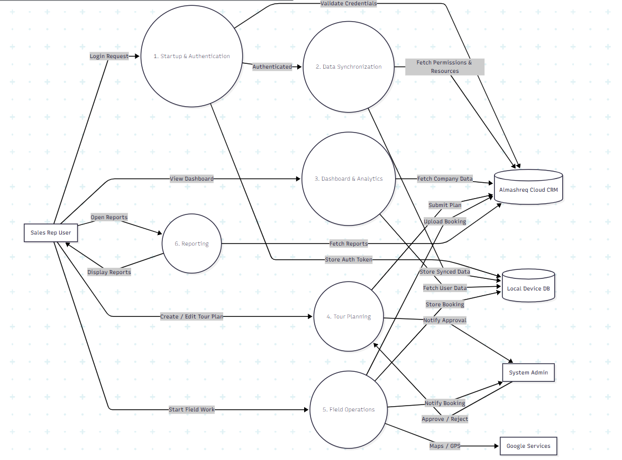

Data Flow Diagram Level 2
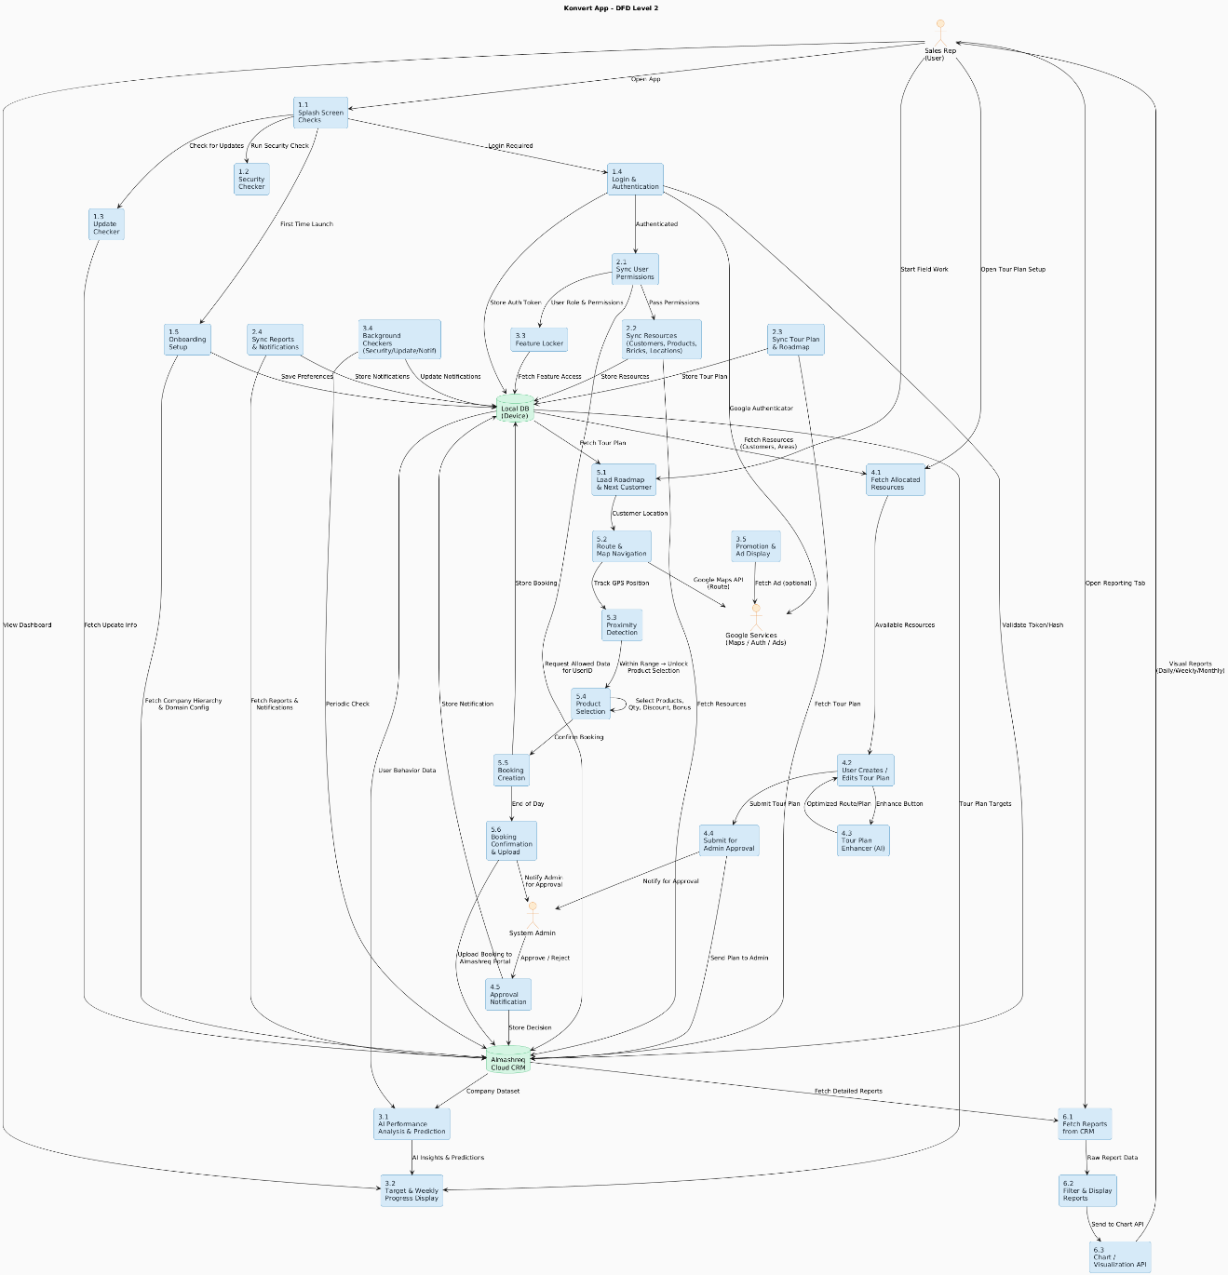

System Design

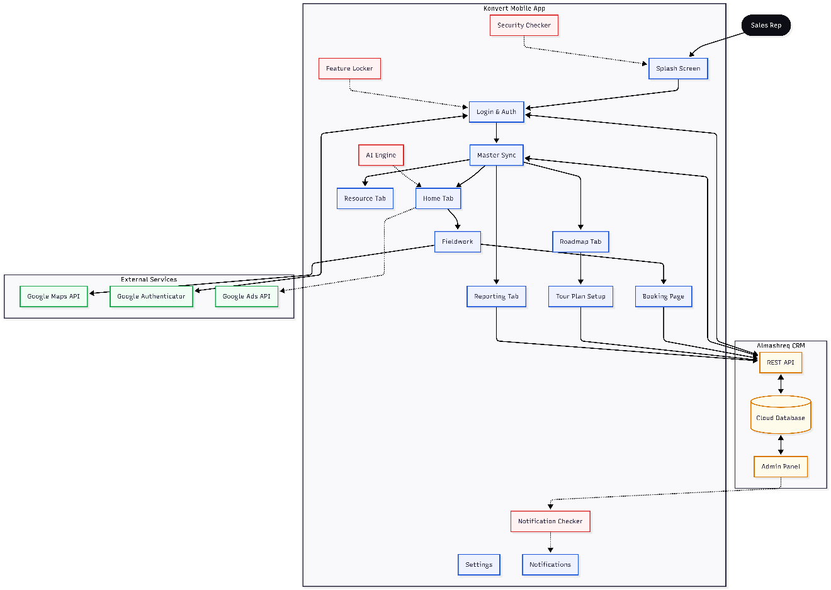
System archtecture Diagram

Class Diagram
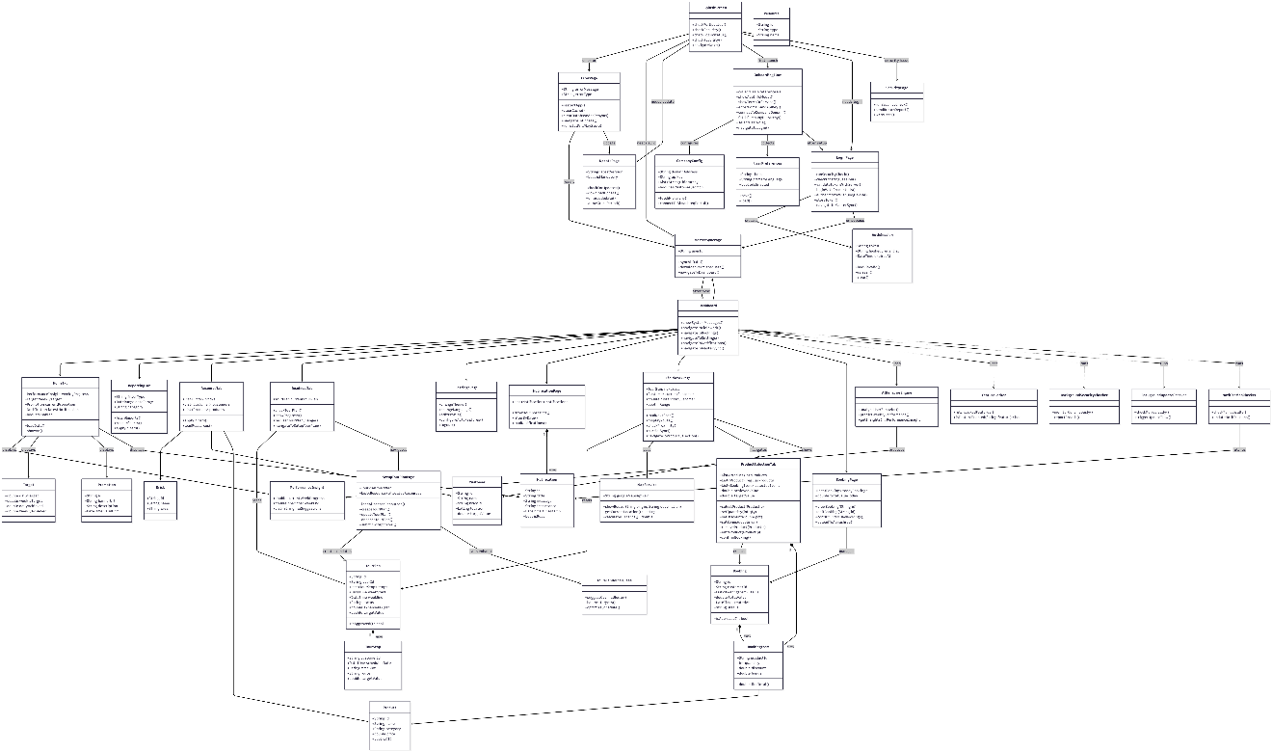

Sequence Diagrams
